**Uncle’s Pension Pinch: India’s Pension Play and Why EPFO Needs a Makeover**

**Under the faint glow of a single bulb, my uncle budgets ₹500 of his ₹1,000 monthly Employees’ Pension Scheme (EPS-95) pension for medicines. “This pension,” he quips, “is one idli at a feast.” His humour masks a harsh truth: inflation has cut his pension to ₹732 in real terms, barely covering rice and dal. I analysed India’s pension system using** [**Indiastat**](https://www.linkedin.com/company/indiastat/) **data with Stata and RStudio. EPS-95 serves 2.06 million minimum pensioners, with subsidies up 6.37% to ₹979.08 crore. A proposed ₹7,500 hike, costing ₹18,499.69 crore. The Hindu faces 2025 hurdles: 5-6% inflation, 2.7-3% pensioner growth, and a ₹19,500 crore cost in a 6.5% GDP economy. By 2025, data planning falters. South Indian states like Andhra Pradesh (₹3,000) and Kerala (up to ₹5,000) offer stronger models. With two visualisations and policy proposals, I explore why my uncle’s pension shrinks—and how to serve a heartier plate.**

**The Pension Landscape: South India’s Thali vs. EPFO’s Morsel**

**South India’s Robust Spread**

**My uncle’s ₹1,000 EPS-95 pension feels like a single idli next to India’s generous pension thali.**

**Table 1 contrasts the systems:**

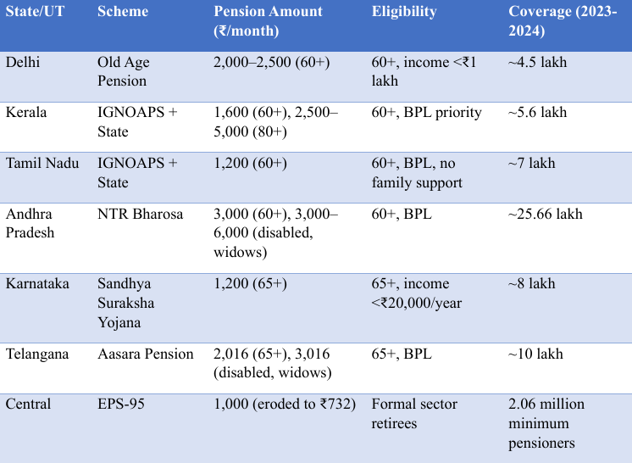

**Delhi’s ₹2,000–₹2,500 supports 4.5 lakh elderly, with extra for SC/ST** [**Delhi Government, 2024**](https://socialwelfare.delhigovt.nic.in/old-age-pension-scheme)**. Kerala supplements central ₹200–₹500 with state funds, providing ₹1,600 (60+) and up to ₹5,000 (80+) for 5.6 lakh, backed by ₹1,604 crore: The** [**Hindu, 2025**](https://www.thehindu.com/news/national/kerala/kerala-govt-to-disburse-two-instalments-of-social-security-pensions/article67757341.ece)**. Tamil Nadu’s ₹1,200 reaches 7 lakh BPL elderly** [**Tamil Nadu Government, 2024**](https://www.tn.gov.in/scheme/social-security)**. Andhra Pradesh’s NTR Bharosa offers ₹3,000 (up to ₹6,000 for special groups) to 25.66 lakh with ₹7,698 crore: The** [**Hindu, 2024**](https://www.thehindu.com/news/national/andhra-pradesh/pension-distribution-commences-in-andhra-pradesh/article68013970.ece)**. Karnataka’s ₹1,200 covers 8 lakh** [**Karnataka Government, 2024**](https://karnataka.gov.in/schemes/sandhya-suraksha)**, and Telangana’s ₹2,016–₹3,016 reaches 10 lakh** [**Telangana Government, 2024**](https://telangana.gov.in/schemes/aasara-pension)**. South India’s pensions, 20–400% higher than EPS-95, leverage budgets like Tamil Nadu’s ₹31.03 lakh crore GDP: the** [**South First, 2025**](https://thesouthfirst.com/karnataka/tamil-nadu-karnataka-among-indias-top-5-contributing-states-to-nsdp-in-2024-25/)**. Andhra’s coverage and Kerala’s tiers outshine EPS-95, but without 2025 data, their sustainability is unclear.**

**Gaps in Coverage and Value**

**EPS-95’s ₹1,000 is a stale dosa beside South India’s hearty meals. It covers 7.8 million formal sector retirees, 26% (2.06 million) at ₹1,000, but excludes 90% of India’s informal workforce** [**Rajan & Asher, 2020**](https://doi.org/10.1111/aepr.12100)**. Andhra’s 25.66 lakh pensioners surpass Delhi’s 4.5 lakh yet miss non-BPL retirees. EPS-95’s real value of ₹732 lags Andhra’s ₹3,000 and Kerala’s ₹5,000, as states adjust for inflation while EPS-95 remains static since 2014: The** [**Hindu, 2024**](https://www.thehindu.com/news/national/andhra-pradesh/pension-distribution-commences-in-andhra-pradesh/article68013970.ece)**. The Centralised Pension Payment System (January 2025) struggles with 30% rural digital exclusion, affecting 600,000 pensioners** [**Telecom Regulatory Authority of India, 2024**](https://www.trai.gov.in/sites/default/files/Annual_Report_2023_2024.pdf)**. Andhra’s local networks perform better, though rural gaps remain—The** [**Hindu, 2024**](https://www.thehindu.com/news/national/andhra-pradesh/pension-distribution-commences-in-andhra-pradesh/article68013970.ece)**. Kerala’s ₹1,604 crore budget faces deficits,** [**PRS India, 2023**](https://prsindia.org/budgets/state-finances-2023-24)**. EPS-95’s subsidies, up 6.37% to ₹979.08 crore, strain finances, with 2025 costs projected at ₹1,041 crore** [**IndiaStat, n.d.**](https://www.indiastat.com/table/finance/3820)**. Without 2025 data, budgeting is uncertain. States prioritise fairness but lack national reach; EPS-95 spans widely but offers little, leaving my uncle coveting Kerala’s approach.**

**The Growing Burden: More Pensioners, Less Purchasing Power**

**A Swelling Pensioner Family**

**Figure 1 - Pensioner Growth**

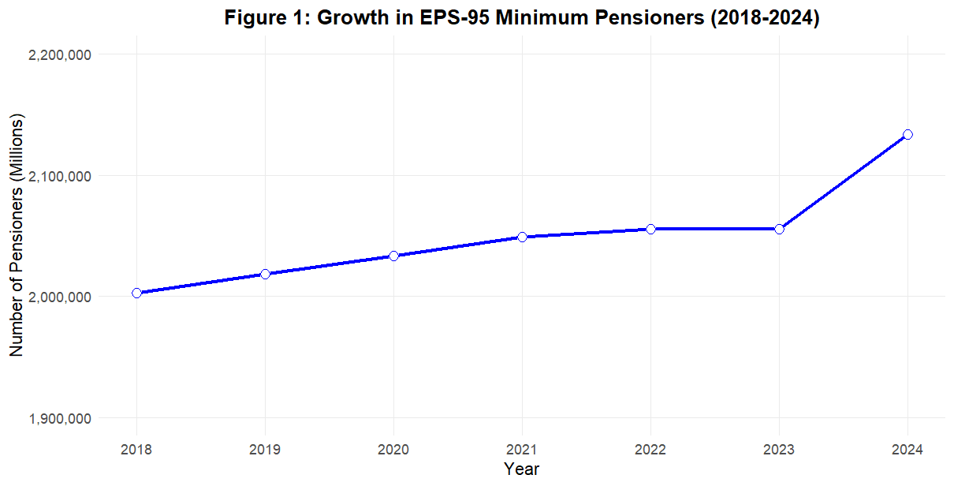

**The above chart shows a blue curve climbing: EPS-95 minimum pensioners grew from 2,003,143 in 2018-2019 to 2,055,521 in 2023-2024, projected to 2,133,630 by Q1 2024 (2.61% growth). The x-axis spans 2018–2024, and the y-axis covers 1.9–2.2 million pensioners. It’s a growing reunion, but the pension plate shrinks for all.**

**Data Point: Using** [**Indiastat**](https://www.linkedin.com/company/indiastat/) **the chart shows EPS-95’s expanding reach, yet its 2.61% growth trails India’s 3-4% elderly population rise,** [**United Nations Population Division, 2023**](https://population.un.org/wpp/)**. A 2.7-3% increase in 2025 could push the ₹7,500 hike’s cost to ₹19,500 crore in a 6.5% GDP economy,** [**International Monetary Fund, 2025**](https://www.imf.org/en/Publications/WEO)**. Without 2025 data, budgeting risks shortfalls. Andhra’s 25.66 lakh pensioners show that large-scale coverage is feasible, but funding must scale up. Policymakers should focus on sustainable budgets, unlike my uncle’s unchanging ₹1,000.**

**A Pension Losing Its Flavour**

**Figure 2 - Nominal vs. Real Pension Value with CPI**

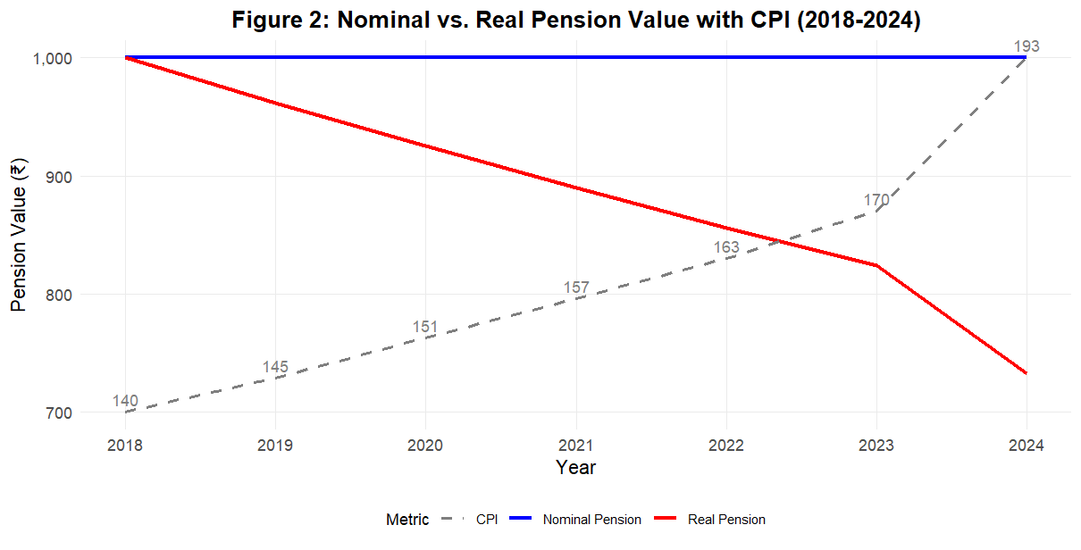

**The above chart paints a grim picture: a blue line steady at ₹1,000 (nominal pension) from 2018–2024, a red line falling from ₹1,000 to ₹732 (absolute value), and a grey dashed line for CPI (140–193), annotated with CPI values. The x-axis covers 2018–2024, and the y-axis spans ₹700–1,000. It’s my uncle’s pension fading like a worn-out shirt.**

**Data Point: Using** [**Indiastat**](https://www.linkedin.com/company/indiastat/) **and** [**GoIStats MoSPI**](https://www.linkedin.com/in/goistats-mospi-2191b3317/)**, the chart reveals a 28% value loss as CPI climbed from 140 to 193. My uncle’s ₹232 after medicines pushes him onto family support. Subsidies rose 6.37% to ₹979.08 crore, outpacing 4.08% disbursements, yet they can’t keep up with inflation. Indiastat. Without 2025 data, the ₹1,041 crore subsidy projection for 2025 is uncertain.** [**Indiastat**](https://www.linkedin.com/company/indiastat/) **. Kerala’s ₹5,000 pension, adjusted for inflation, shames EPS-95’s stagnation. It should prioritise CPI indexing and address digital gaps (30% rural exclusion),** [**Telecom Regulatory Authority of India (TRAI)**](https://www.linkedin.com/company/trai-official/)

**Policy Solutions: Crafting a Tastier Pension Plan**

**The ₹7,500 hike, costing ₹18,499.69 crore, could let my uncle buy rice, medicines, and a rickshaw ride, with the Centralised Pension Payment System (January 2025) streamlining delivery—theBut challenges loom: 6.37% subsidy growth, 10% fuel price rises, the** [**International Energy Agency (IEA)**](https://www.linkedin.com/company/international-energy-agency/) **and 30% rural digital exclusion. Costs may hit ₹19,500 crore in 2025, but no 2025 data make projections shaky (5-6% inflation, 2.7-3% pensioner growth),** [**International Monetary Fund**](https://www.linkedin.com/company/international-monetary-fund/)**. Low pensions cost local shops ₹500 crore.**

**I would like to propose the following.**

1. **Tiered Contributions: High earners (₹50,000+) pay 1.5%, low earners 0.5%, raising ₹2,000 crore,** [**Asher & Bali, 2015**](https://doi.org/10.1111/aepr.12100)**. It’s like the wealthy uncle adding curry to the pot.**
2. **CPI Indexing: Tie pensions to CPI, as Chile’s system gained 15% efficiency,** [**World Bank, 2018**](https://www.worldbank.org/en/region/lac/publication/pension-systems-latin-america)**. Kerala’s model proves it works.**
3. **Pilot Programs: Test state-central hybrids in high-coverage states like Andhra, using ₹500 crore to fix digital gaps. High earners may resist, and digital infrastructure needs investment. Without 2025 data, pilots are critical. Andhra’s ₹7,698 crore and Kerala’s ₹1,604 crore show states lead, but national scaling requires better data.**

**Conclusion: From Struggle to Solutions**

**My uncle’s ₹1,000 pension, now ₹732, is a sad jest—only inflation’s laughing. Figures 1 and 3 show 2.06 million pensioners and a dwindling pension value, with the ₹7,500 hike’s ₹19,500 crore cost looming. The absence of 2025 data clouds budgeting in a 6.5% GDP economy** [**International Monetary Fund, 2025**](https://www.imf.org/en/Publications/WEO)**. Andhra’s ₹3,000 and Kerala’s ₹5,000 pensions adjust for inflation, unlike EPS-95—The** [**Hindu, 2024**](https://www.thehindu.com/news/national/andhra-pradesh/pension-distribution-commences-in-andhra-pradesh/article68013970.ece)**;** [**The Hindu, 2025**](https://www.thehindu.com/news/national/kerala/kerala-govt-to-disburse-two-instalments-of-social-security-pensions/article67757341.ece)**. My uncle’s reliance on family and ₹500 crore in lost local spending, National Council of Applied Economic Research, 2023, demands change. I urge tiered contributions, CPI indexing, and pilots to close data gaps by 2030, ensuring no retiree faces a one-idli future.**

**References**

* **Haozhaopian. (2025). AI-generated artwork [AI-generated image]. Haozhaopian.** [**https://u-static.haozhaopian.net/uid_1341d681a6ef49b2a87d070c5bef10ea/aiImage/d1eaea6075d7481081d9e491d2ed6124.jpg**](https://u-static.haozhaopian.net/uid_1341d681a6ef49b2a87d070c5bef10ea/aiImage/d1eaea6075d7481081d9e491d2ed6124.jpg)
* **Asher, M., & Bali, A. S. (2015). Public pension programs in Southeast Asia: an assessment. *Asian Economic Policy Review*, *10*(2), 225–245.** [**https://doi.org/10.1111/aepr.12100**](https://doi.org/10.1111/aepr.12100)
* **Delhi Government. (2024). Old Age Pension Scheme.** [**https://socialwelfare.delhigovt.nic.in/old-age-pension-scheme**](https://socialwelfare.delhigovt.nic.in/old-age-pension-scheme)
* **IndiaStat. *Number of Pensioners Affected and Amount Disbursed for Implementing Minimum Pension under Employees Provident Fund Organisation (EPFO) in India  (2018-2019 to 2023-2024)*. (n.d.).** [**https://www.indiastat.com/table/labour-and-workforce/number-pensioners-affected-amount-disbursed-implem/1467687**](https://www.indiastat.com/table/labour-and-workforce/number-pensioners-affected-amount-disbursed-implem/1467687)
* **International Monetary Fund. (2025). World Economic Outlook.** [**https://www.imf.org/en/Publications/WEO**](https://www.imf.org/en/Publications/WEO)
* **Karnataka Government. (2024). Sandhya Suraksha Yojana.** [**https://www.dssp.karnataka.gov.in/dssp/Sandhya_Suraksha.aspx**](https://www.dssp.karnataka.gov.in/dssp/Sandhya_Suraksha.aspx)
* ***Ministry of Statistics and Program Implementation | Government of India*. (n.d.).** [**https://esankhyiki.mospi.gov.in/macroindicators?product=cpi**](https://esankhyiki.mospi.gov.in/macroindicators?product=cpi)
* **PRS India. (2023). State Finances 2023-24.** [**https://prsindia.org/budgets/state-finances-2023-24**](https://prsindia.org/budgets/discussionpapers/state-of-state-finances-2023-24)
* ***Rajan, S. I., & Asher, M. G. (2020). Pension systems in India: challenges and opportunities. Springer - Bing*. (n.d.). Bing.** [**https://www.bing.com/search?q=Rajan%2C+S.+I.%2C+%26+Asher%2C+M.+G.+(2020).+Pension+Systems+in+India%3A+Challenges+and+Opportunities.+Springer&gs_lcrp=EgRlZGdlKgYIABBFGDkyBggAEEUYOagCALACAA&FORM=ANCMS9&ucpdpc=UCPD&PC=LCTS**](https://www.bing.com/search?q=Rajan%2C+S.+I.%2C+%26+Asher%2C+M.+G.+(2020).+Pension+Systems+in+India%3A+Challenges+and+Opportunities.+Springer&gs_lcrp=EgRlZGdlKgYIABBFGDkyBggAEEUYOagCALACAA&FORM=ANCMS9&ucpdpc=UCPD&PC=LCTS)
* **Tamil Nadu Government. (2024). Social Security Schemes.** [**https://www.tn.gov.in/scheme/social-security**](https://www.tn.gov.in/scheme/social-security)
* **Telangana Government. (2024). Aasara Pension Scheme.** [**https://telangana.gov.in/schemes/aasara-pension**](https://telangana.gov.in/schemes/aasara-pension)
* **M, S. R. (2024, April 3). *Pension distribution commences in Andhra Pradesh*. The Hindu.** [**https://www.thehindu.com/news/national/andhra-pradesh/pension-distribution-commences-in-andhra-pradesh/article68025693.ece**](https://www.thehindu.com/news/national/andhra-pradesh/pension-distribution-commences-in-andhra-pradesh/article68025693.ece)
* **The Hindu Bureau. (2025, January 20). Kerala's government will disburse two social security and welfare fund board pensions on *January 24*. The Hindu.** [**https://www.thehindu.com/news/national/kerala/kerala-govt-to-disburse-two-instalments-of-social-security-welfare-fund-board-pensions-from-jan-24/article69119197.ece#:~:text=The%20Kerala%20Finance%20department%20has%20authorised%20the%20release,Minister%20K.N.%20Balagopal%20said%20on%20Monday%20%28January%2020%29**](https://www.thehindu.com/news/national/kerala/kerala-govt-to-disburse-two-instalments-of-social-security-welfare-fund-board-pensions-from-jan-24/article69119197.ece#:~:text=The%20Kerala%20Finance%20department%20has%20authorised%20the%20release,Minister%20K.N.%20Balagopal%20said%20on%20Monday%20%28January%2020%29)**.**
* ***Pensioners’ delegation calls upon Finance Minister; demands ₹7,500 minimum monthly pension under EPS-95*. The Hindu.** [**https://www.thehindu.com/business/Economy/pensioners-delegation-calls-upon-finance-minister-demands-7500-minimum-monthly-pension-under-eps-95/article69087812.ece#:~:text=A%20delegation%20of%20EPS-95%20pensioners%20met%20Finance%20Minister,pension%20of%20%E2%82%B97%2C500%20along%20with%20dearness%20allowance%20%28DA%29**](https://www.thehindu.com/business/Economy/pensioners-delegation-calls-upon-finance-minister-demands-7500-minimum-monthly-pension-under-eps-95/article69087812.ece#:~:text=A%20delegation%20of%20EPS-95%20pensioners%20met%20Finance%20Minister,pension%20of%20%E2%82%B97%2C500%20along%20with%20dearness%20allowance%20%28DA%29)**.**
* **Desk, S. F. (2025, April 7). Tamil Nadu and Karnataka are among India’s top 5 contributing states to NSDP in 2024-25. *The South First*.** [**https://thesouthfirst.com/news/tamil-nadu-karnataka-among-indias-top-5-contributing-states-to-nsdp-in-2024-25/**](https://thesouthfirst.com/news/tamil-nadu-karnataka-among-indias-top-5-contributing-states-to-nsdp-in-2024-25/)
* **World Bank. (2018). Pension Systems in Latin America. World Bank Document** [**https://documents1.worldbank.org/curated/en/434441468266716321/pdf/381700NWP0REVI16010Updated0version0.pdf**](https://documents1.worldbank.org/curated/en/434441468266716321/pdf/381700NWP0REVI16010Updated0version0.pdf)